Handwritten Digit Recognition Using K-Nearest Neighbors and Support Vector Machine on the MNIST Dataset

Greeshma Sai
Dept. of Computer Science & Engineering
Koneru Lakshmaiah Education Foundation, Hyderabad
Roll No. 2420030550
Keerthi Reddy
Dept. of Computer Science & Engineering
Koneru Lakshmaiah Education
Foundation, Hyderabad
Roll No. 2420030774
Dr. N. Sunanda
Associate Professor, Dept. of CSE
Koneru Lakshmaiah Education
Foundation, Hyderabad
(Project Guide)
Hasini Peddi
Dept. of Computer Science & Engineering
Koneru Lakshmaiah Education
Foundation, Hyderabad
Roll No. 2420030784

Abstract—Handwritten digits vary widely in shape, size, slant, and stroke thickness, which makes automatic recognition a challenging pattern-recognition problem, while manual transcription of large digit collections is slow and error-prone. This paper presents a complete, reproducible study of handwritten digit recognition with two classical supervised classifiers, K-Nearest Neighbors (KNN) and Support Vector Machine (SVM), on the MNIST benchmark. The pipeline covers exploratory analysis, pixel normalization, stratified splitting, cross-validated hyper-parameter selection, and evaluation with accuracy, precision, recall, F1-score, confusion matrices, and a McNemar significance test. In a first experiment on a class-balanced subset of 5,000 real MNIST images (4,000 for training, 1,000 for testing), KNN (k = 1) reached 93.0% test accuracy and an RBF-kernel SVM reached 95.7%, a difference that is statistically significant (p < 0.001). Errors concentrate on visually similar pairs such as 3/5, 4/9, and 7/9. The paper also reports the literature survey, problem gap, novelty, feasibility, and a 14-week project plan, and outlines extension to the full 70,000-image dataset and to real-world documents.
Keywords—Handwritten Digit Recognition, MNIST, K-Nearest Neighbors, Support Vector Machine, Image Classification, Machine Learning, Confusion Matrix

Introduction
Handwritten digit recognition is one of the oldest and most widely studied problems in pattern recognition and computer vision. A system that reads handwritten digits must map an image of a hand-drawn numeral to one of ten classes, 0 through 9. Although the number of classes is small, the problem is far from trivial: every writer forms the same digit differently, and even one writer never reproduces a digit identically. Strokes differ in thickness, slant, size, and completeness; loops may be open or closed; and some digit pairs, such as 3 and 5 or 4 and 9, are visually close enough to confuse even human readers when written quickly.
The practical importance of the task is considerable. Postal services read handwritten ZIP codes to route mail, banks read the amount fields on cheques and deposit slips, universities digitize hand-filled examination and attendance sheets, and government offices convert paper forms into databases. Manually keying in large volumes of such digits is time-consuming, tiring, and error-prone, which creates a clear need for an automatic recognition system that is accurate, fast, and inexpensive to deploy.
The Modified National Institute of Standards and Technology (MNIST) database [1], [17] has become the standard benchmark for this problem. It provides 70,000 centred, size-normalized grayscale images (Fig. 1) of handwritten digits and a fixed train/test split, which allows results from different studies to be compared on common ground. State-of-the-art deep convolutional networks now exceed 99.5% accuracy on MNIST [1], [9], but they typically require substantial computation and offer limited interpretability. Classical machine-learning classifiers remain attractive in teaching, prototyping, and resource-constrained settings because they are easy to implement, have few hyper-parameters, and their behaviour can be inspected and explained.
This work studies two such classifiers, K-Nearest Neighbors (KNN) [5] and Support Vector Machine (SVM) [6]. KNN is an instance-based method that classifies a new image by a vote among the most similar training images, while SVM learns a maximum-margin decision boundary in a (possibly kernelized) feature space. Both are trained and tested on identical data under identical conditions so that the comparison is fair, and both are examined not only through overall accuracy but also through precision, recall, F1-score, confusion matrices, per-class behaviour, computational cost, and sensitivity to training-set size and dimensionality reduction.
The main contributions of this paper are: (i) a literature survey and explicit problem-gap analysis for handwritten digit recognition; (ii) a reproducible end-to-end pipeline for KNN and SVM covering exploration, preprocessing, tuning, and evaluation; (iii) an empirical comparison on real MNIST images with a statistical significance test and a class-level error analysis; (iv) a discussion of novelty, feasibility, applications, and limitations; and (v) a 14-week project plan for scaling the study to the full dataset and to real documents.
The remainder of the paper is organized as follows. Section II surveys related work. Section III states the problem and the research gap, and Section IV lists the objectives. Sections V to X describe the dataset, preprocessing, system workflow, the two classifiers, and the evaluation metrics. Section XI presents the experimental setup and Section XII the results and discussion. Sections XIII to XVII cover novelty, feasibility and project plan, applications, limitations, and future work, and Section XVIII concludes.

Literature Survey

Classical Machine-Learning Approaches
Early work on digit recognition relied on hand-crafted features and statistical classifiers. The nearest-neighbour rule of Cover and Hart [5] showed that, as the training set grows, the error of a 1-NN classifier is bounded by twice the Bayes error, which explains why KNN is a strong baseline when plenty of labeled data is available. Support vector machines, introduced by Cortes and Vapnik [6], added the idea of maximizing the margin between classes and, through kernels, of separating classes that are not linearly separable in the original pixel space. The original MNIST study by LeCun et al. [1] compared linear classifiers, KNN, SVMs, multilayer perceptrons, and convolutional networks on the same split and established the reference error rates against which later work is measured; on the full dataset, plain Euclidean KNN is reported at an error of a few percent, while Gaussian-kernel SVMs reach roughly 1 to 1.5% error [17]. Practical guidance for SVM use, such as scaling the inputs and searching the cost and kernel parameters on a logarithmic grid, is given in [11], [12].

Deep-Learning Approaches
Convolutional neural networks (CNNs) learn their own features directly from pixels and have become the dominant approach. Zhang et al. [2] proposed ResNet18-ThunderSVM, in which a ResNet18 backbone extracts deep spatial features automatically and a high-performance SVM acts as the final classifier; the model was evaluated on MNIST, EMNIST, USPS, and Fashion-MNIST, and the authors report better generalization and robustness to noisy data than using manual feature engineering. Sethi and Pareek [4] studied optical handwritten digit recognition with several deep-learning models on MNIST and found that a VGG16 network reached 98.53% accuracy, although their evaluation relies mainly on classification accuracy on the benchmark.

Hybrid and Brain-Inspired Approaches
Combining feature learning with SVM classification has a long history. Bellili et al. [8] used specialized local SVMs to resolve the two most likely classes proposed by a multilayer perceptron, improving recognition of confusable digit pairs on real mail ZIP-code digits. Niu and Suen [7] used a CNN as a trainable feature extractor and an SVM as the recognizer, and reported a recognition rate of 99.81% on MNIST without rejection. Fang and Yang [9] replaced the last layer of a modified LeNet by a linear SVM and obtained 99.31% test accuracy. A different line of work explores biologically inspired models: Guo and Wang [3] constrained the topology of a spiking neural network with number-related functional brain topology derived from task-fMRI data and obtained 97.27% accuracy on MNIST, which demonstrates the potential of brain-inspired computing even though the topology-to-network mapping remains fixed and the dataset is relatively simple.
- Summary of the Literature Survey
Ref. | Method | Key finding | Limitation / future work
[2] | ResNet18 features + ThunderSVM; MNIST, EMNIST, USPS, Fashion-MNIST | Automatic features reduce manual engineering; robust to noisy data | Model pruning, lightweight ResNets, harder datasets
[3] | fMRI-derived topology for spiking neural network; MNIST | 97.27% accuracy; brain-inspired computing is promising | Fixed topology mapping; simple dataset
[4] | Deep models (VGG16 etc.) on MNIST | VGG16 reached 98.53% accuracy | Benchmark-only; mainly accuracy-based
[7] | CNN feature extractor + SVM recognizer | 99.81% on MNIST without rejection | Heavier training than classical models
[8] | MLP with specialized local SVMs | Better handling of confusable digit pairs | Complex multi-stage architecture
[9] | Modified LeNet + linear SVM | 99.31% test accuracy on MNIST | No augmentation; benchmark-only

Taken together, these studies show that deep and hybrid models achieve very high accuracy on MNIST, but they rely on complex architectures, are evaluated almost exclusively on the standard benchmark, and rarely examine class-level errors or computational cost. They therefore leave room for a transparent study of well-understood classical models that explains where and why errors occur.

Evaluation Practices in the Literature
Most of the surveyed work reports a single accuracy figure on the standard 10,000-image MNIST test set. This practice makes results easy to compare but has three weaknesses. First, with accuracies above 99%, the differences between methods are only a few images and often smaller than the sampling uncertainty. Second, tuning choices made while watching test performance may leak information into the reported numbers. Third, a single figure says nothing about which digits fail or what the model costs in time and memory. This study therefore uses cross-validation for tuning, reserves the test set for one final evaluation, adds a paired significance test, and reports per-class behaviour and computational cost alongside accuracy.

Problem Statement and Gap Identification
Handwritten digits differ in shape, size, orientation, and writing style, which makes automatic recognition challenging. These variations make it difficult for computers to recognize digits accurately, and manually identifying large numbers of handwritten digits is time-consuming and error-prone. The problem addressed here is to design, implement, and evaluate a system that automatically recognizes and classifies handwritten digits from 0 to 9, using the MNIST dataset to study digit patterns, and the KNN and SVM algorithms to perform the classification, with performance judged by accuracy, precision, recall, F1-score, and a confusion matrix.
Formally, given a grayscale image x of 28 × 28 pixels, flattened into a vector of d = 784 intensity values, the goal is to learn a function f that maps x to a label y ∈ {0, 1, …, 9} such that the error on previously unseen images from different writers is minimal.
- Identified Research Gaps
Existing work | Gap identified
VGG16, ResNet18, and Vision Transformers reach high accuracy | Evaluation focuses on MNIST and may not represent diverse real-world handwriting
Preprocessing and normalization improve recognition | May not fully handle variation in style, size, shape, and stroke thickness
Spiking and brain-inspired networks | Fixed architectures; need validation on complex datasets
Most studies report classification accuracy | Accuracy, efficiency, robustness, and generalization are rarely considered together
Studies address individual aspects | A practical, explainable system combining these aspects is still needed

The gap is therefore not a lack of accuracy on MNIST, but the absence of a transparent, reproducible comparison that links model performance to its cost, to the amount of training data, to preprocessing choices, and to the specific digit classes on which errors occur. This study is designed to supply exactly that evidence for two classical and widely taught classifiers.

Objectives
- To develop a system that can automatically recognize handwritten digits from 0 to 9.
- To use the MNIST dataset for training and testing the handwritten digit recognition models.
- To preprocess and normalize the image data so that it can be used effectively by the machine-learning models.
- To explore the dataset using basic data analysis and visualization to understand digit patterns and class distribution.
- To implement K-Nearest Neighbors (KNN) and Support Vector Machine (SVM) for digit classification.
- To compare the performance of KNN and SVM using suitable evaluation metrics.
- To identify and understand classification errors between different digit classes using a confusion matrix.

Dataset and Exploratory Analysis

The MNIST Database
MNIST was constructed by LeCun, Cortes, and Burges [17] from the NIST Special Database 3 (digits written by Census Bureau employees) and Special Database 1 (digits written by high-school students). It contains 60,000 training images and 10,000 test images; the training and test writers are disjoint, so test accuracy measures generalization to unseen writers. Each digit was size-normalized to fit a 20 × 20 pixel box while preserving the aspect ratio, anti-aliased to produce gray levels, and centred by center of mass in a 28 × 28 image. Every pixel holds an integer intensity from 0 (background) to 255 (full stroke).
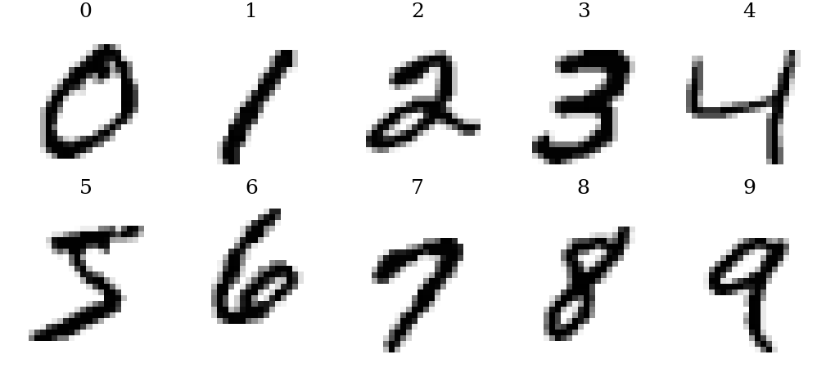
- One example of each digit class taken from the MNIST data used in this study.

Class Distribution
The ten classes are almost balanced in the full training set, ranging from 5,421 images for digit 5 to 6,742 images for digit 1 (Fig. 2). Such mild imbalance means that accuracy is a meaningful headline metric, but per-class precision and recall are still needed to detect classes that are systematically harder. The subset used in the experiments of Section XII is exactly balanced with 500 images per class.
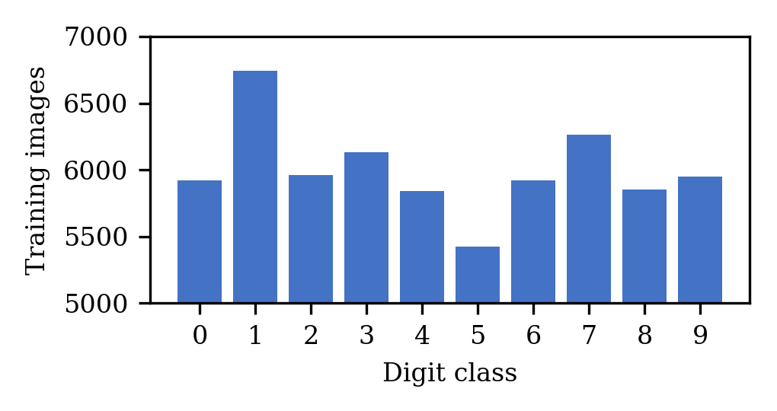
- Number of training images per digit class in the full MNIST training set (60,000 images).
Visual inspection of samples reveals the sources of difficulty: the digit 1 may be drawn as a single stroke or with a flag and base; 7 may carry a crossbar; 4 may be open or closed at the top; and 9 may be written with an open or closed loop, which makes it resemble 4 or 7. These observations motivate the focus on similar-digit errors throughout the paper.

Data Preprocessing
Preprocessing converts raw images into a numerical representation suitable for the classifiers and removes variation that is not informative. Three steps are applied consistently to training and test data.
Flattening. Each 28 × 28 image is unrolled row by row into a vector x ∈ ℝ⁷⁸⁴. This discards the explicit two-dimensional neighbourhood structure, but it is the standard input format for KNN and kernel SVMs and keeps the pipeline simple and fast.
Normalization. Pixel intensities are rescaled from [0, 255] to [0, 1] as in (1). Distance-based learners such as KNN and kernel methods such as SVM are sensitive to feature scale, and normalization also keeps the numerical range of the kernel stable.
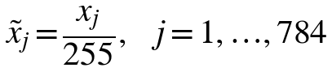 (1)
Stratified splitting. The labeled data is split into training and test sets so that every class has the same proportion in both parts. Hyper-parameters are chosen by five-fold stratified cross-validation on the training part only, and the test part is used exactly once for the final report, which prevents optimistic bias caused by tuning on test data.
Optional dimensionality reduction. Principal component analysis (PCA) projects the 784-dimensional vectors onto the k directions of largest variance, as in (2), where μ is the training mean and Wₖ holds the first k principal axes. Because neighbouring pixels are strongly correlated, a small number of components captures most of the variance, which reduces both noise and computation. Its effect on KNN and SVM is evaluated in Section XII.
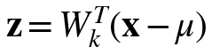 (2)
Further preprocessing that is relevant for real documents, but not needed for the already-normalized MNIST images, includes binarization or thresholding, noise removal, deskewing, centring by center of mass, and size normalization. These are identified as future work in Section XVII.

Proposed System and Workflow
The proposed system is a supervised machine-learning workflow that takes a labeled digit image collection as input and produces two trained classifiers together with a quantitative and qualitative comparison between them. The workflow, shown in Fig. 3, is deliberately linear and transparent so that each step can be checked and repeated.
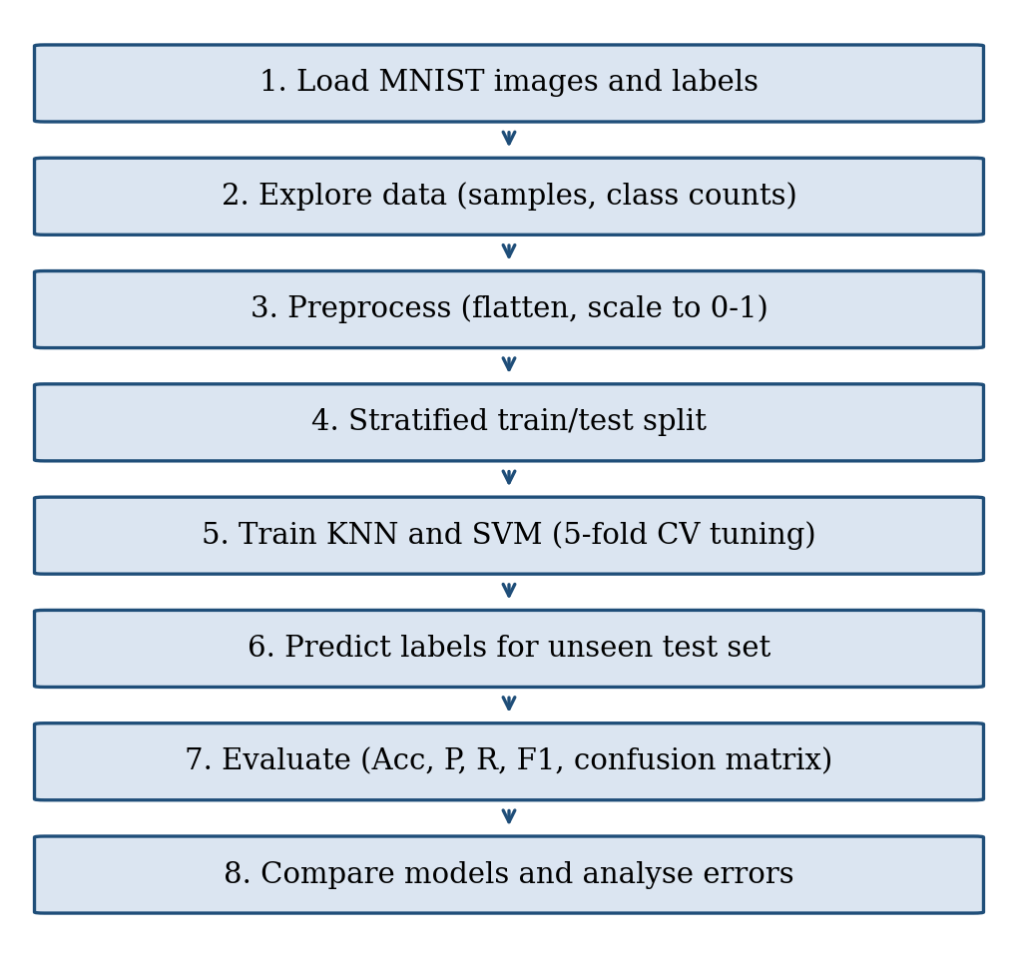
- Workflow of the proposed handwritten digit recognition system.
The implementation uses Python with NumPy [14] for array handling, scikit-learn [10] for the classifiers, cross-validation and metrics, and Matplotlib [15] for visualization; the SVM implementation in scikit-learn is built on LIBSVM [11]. At prediction time, a new image passes through the same flatten-and-normalize steps and is sent to the selected classifier, which returns a digit label in a fraction of a second.

System Modules
The system is organized into five loosely coupled modules so that each can be tested, replaced, or extended independently, as listed in Table III. This separation also mirrors the project phases in Section XIV: the data and preprocessing modules belong to phase 2, the model module to phases 3 and 4, the evaluation module to phase 5, and the prediction interface to phase 6.
- System Modules and Responsibilities
Module | Responsibility | Tools
Data | Load labeled images, check shapes and label range, stratified split | NumPy, MLxtend
Preprocessing | Flatten, normalize, optional PCA; identical for train and test | NumPy, scikit-learn
Model | Fit and tune KNN and SVM with cross-validation | scikit-learn, LIBSVM
Evaluation | Metrics, confusion matrices, McNemar test, timing | scikit-learn, SciPy
Prediction interface | Accept an image, apply preprocessing, return digit and score | Python, OpenCV

Algorithmic Steps
The training and prediction procedures of the two classifiers can be summarized as follows.
- KNN training: store the normalized training vectors and their labels; select k by cross-validation.
- KNN prediction: compute the distance from the query to all stored vectors, select the k smallest, and return the majority label.
- SVM training: for each of the 45 digit pairs, solve the soft-margin problem with the RBF kernel and record the support vectors and coefficients.
- SVM prediction: evaluate the decision function of every pairwise classifier on the query and return the label with most votes.

Reproducibility
All random operations use fixed seeds, the split is stratified, and the same preprocessing object is fitted on training data only and then applied unchanged to test data. The complete experiment, from loading the data to producing every table and figure of this paper, runs in about a minute on an ordinary laptop, so a reader can repeat it and verify the numbers. For the full-dataset study, the same scripts are re-run with the 60,000/10,000 official split, and the library versions are recorded together with the results to avoid silent changes in default parameters between releases.

K-Nearest Neighbors
KNN is a non-parametric, instance-based classifier [5]. Training consists only of storing the labeled training vectors; all computation is deferred to prediction time. To classify a query image x, the algorithm computes its distance to every training image, selects the k closest ones, which form the neighbourhood Nₖ(x), and returns the most frequent label among them.
The default distance is the Euclidean distance in pixel space, given by (3); the Manhattan distance in (4) is a common alternative that is less sensitive to a few large pixel differences.
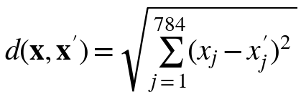 (3)
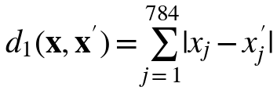 (4)
The predicted label is the majority vote in (5), where δ(yᵢ, c) equals 1 if yᵢ = c and 0 otherwise. A distance-weighted variant, (6), gives closer neighbours more influence.
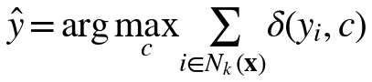 (5)
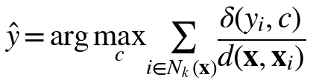 (6)
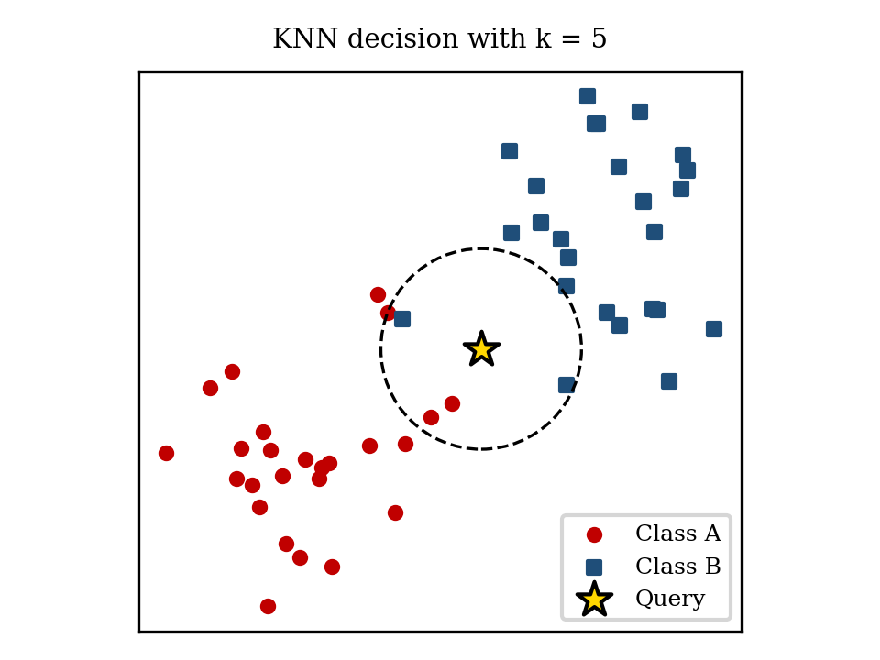
- KNN decision for a query point with k = 5 (illustrative two-dimensional example).
The key hyper-parameter is the neighbourhood size k. A very small k gives a flexible boundary that can follow noise, whereas a large k smooths the boundary and may blur small classes. KNN has no training cost and is easy to explain, but each prediction costs O(n d) distance computations for n training images of dimension d, and the whole training set must be stored. For 60,000 images of 784 dimensions this is manageable for offline evaluation but slow for real-time use unless approximate search structures or dimensionality reduction are used.

Choice of k and the Curse of Dimensionality
The value of k controls the bias–variance trade-off of KNN. With k = 1 the classifier has low bias but high variance: it reproduces the training data perfectly and every mislabeled or atypical training image creates a small region of wrong predictions. Larger values of k average over more neighbours, which lowers variance but raises bias, because neighbours from other classes start to enter the vote. An odd k avoids ties in binary problems, but in a ten-class problem ties can still occur and are usually broken in favour of the nearest neighbour. In practice k is selected by cross-validation, as done in Section XII.
KNN also suffers from the curse of dimensionality: in very high-dimensional spaces, distances between points become less informative because the nearest and the farthest neighbour have similar distances. MNIST is a favourable case, because the 784 pixel values are highly redundant and the data lie close to a much lower-dimensional manifold, which is why Euclidean KNN works well on it and why PCA, which exposes this lower-dimensional structure, does not hurt and can even improve accuracy. On data without such structure, KNN on raw features would perform considerably worse.

Support Vector Machine
An SVM finds the separating hyper-plane that maximizes the margin between two classes [6]. For non-separable data, a soft-margin formulation allows some training points to violate the margin by slack amounts ξᵢ, and the cost parameter C controls the trade-off between a wide margin and few violations, as in (7) and (8), where φ maps the input into a feature space.
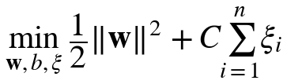 (7)
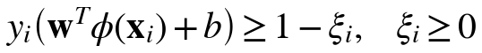 (8)
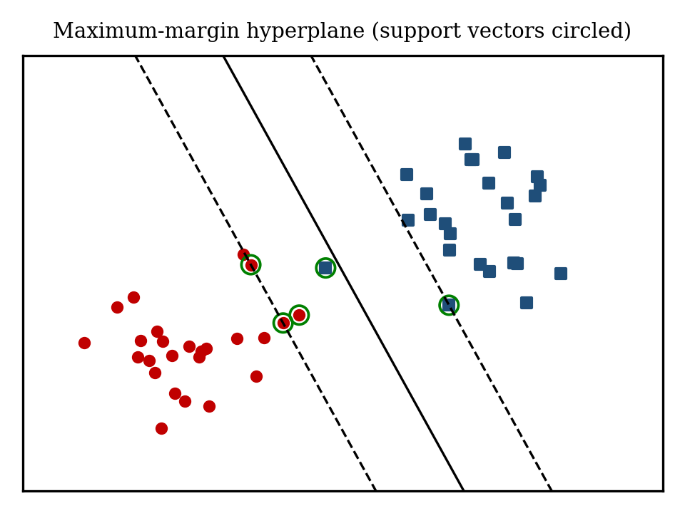
- Maximum-margin separating hyper-plane with support vectors (illustrative two-dimensional example).
Handwritten digits are not linearly separable in pixel space, so a kernel function is used to compute inner products in a high-dimensional feature space without constructing it explicitly. The radial basis function (RBF) kernel in (9) is the most common choice; its width parameter γ controls how far the influence of a single training image reaches. The resulting decision function (10) depends only on the support vectors, which are the training images on or inside the margin.
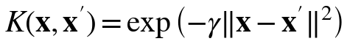 (9)
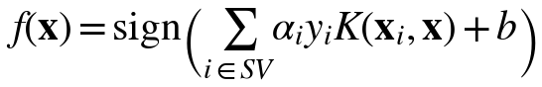 (10)
SVMs are binary classifiers, so the ten-class digit problem is decomposed. The scikit-learn implementation uses the one-versus-one scheme, which trains 45 binary SVMs (11), one for each pair of digits, and assigns the label that wins the most pairwise votes. With γ set to the ‘scale’ heuristic (12), where Var(X) is the variance of all training pixel values, the kernel adapts automatically to the data scale.
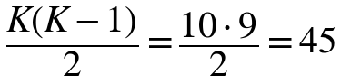 (11)
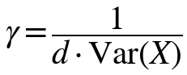 (12)
Training an SVM is more expensive than KNN, with cost growing between quadratically and cubically in the number of training samples, but prediction only involves the support vectors and is therefore usually faster than scanning the entire training set. The hyper-parameters C and γ are chosen by cross-validated grid search on a logarithmic scale, as recommended in [12].

Role of the Parameters C and γ
The cost C and the kernel width γ jointly determine the complexity of the SVM. A small C tolerates many margin violations and produces a smooth, simple boundary that may underfit, while a large C punishes violations heavily and can fit noise. A small γ makes each support vector influence a wide region and gives an almost linear boundary, whereas a large γ makes the influence local and can lead to overfitting, in which every training image becomes its own island. Because the best values interact, they are searched together on a logarithmic grid, and the ‘scale’ default of γ provides a robust starting point so that the search can concentrate on C.

Multi-Class Strategies
Besides one-versus-one, the one-versus-rest strategy trains ten classifiers, each separating one digit from all others. It needs fewer models, but each model is trained on the complete, unbalanced data (one class against nine), while the 45 one-versus-one models are each trained on only about a fifth of the data, which makes their individual training faster and often makes the overall training time smaller for kernel methods. The one-versus-one voting scheme is the default in LIBSVM [11] and in scikit-learn and is the one used in this study.

Evaluation Metrics
Model quality is measured on the held-out test set using the following metrics, where, for a class c, TP(c), FP(c), and FN(c) are the numbers of true positives, false positives, and false negatives, and N is the number of test images.
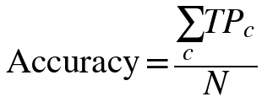 (13)
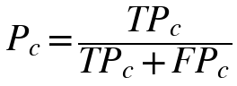 (14)
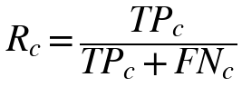 (15)
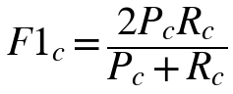 (16)
Accuracy in (13) is the fraction of correctly classified images. Precision (14) tells how many images predicted as class c really belong to c, recall (15) tells how many images of class c were found, and the F1-score (16) is their harmonic mean. Overall values are reported as macro averages, in (17), which give each digit equal weight.
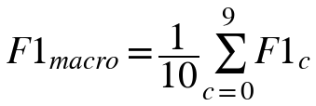 (17)
The confusion matrix is a 10 × 10 table whose entry (i, j) counts test images of true digit i predicted as digit j. The diagonal holds correct predictions, and large off-diagonal entries reveal which digit pairs are mistaken for each other, which is the basis for the error analysis in Section XII. Finally, to decide whether a difference between two classifiers on the same test set is larger than chance, McNemar’s test [13] is applied to the images that exactly one of the two models misclassifies. With b and c denoting the counts of images misclassified only by the first or only by the second model, the statistic (18) follows a chi-square distribution with one degree of freedom.
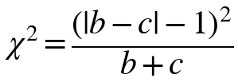 (18)

Why Several Metrics Are Needed
A single number can hide important behaviour. On a strongly imbalanced problem a model that always predicts the majority class obtains high accuracy and zero recall for the other classes. Although MNIST is nearly balanced, the cost of an error is not the same for all applications: on a cheque, reading a 1 as 7 may change an amount by a large factor, so per-class recall and the confusion matrix are the quantities that reveal such risks. Macro averaging, used here, treats all digits equally, whereas micro averaging, which pools all decisions, equals accuracy for single-label problems. Reporting all of them together with the significance test gives a more honest and complete comparison than accuracy alone.

Experimental Setup
The full 70,000-image MNIST database is the target of the project (Section XIV). For this first experimental stage, a class-balanced subset of 5,000 real MNIST images (500 per digit) distributed with the MLxtend library [16] was used, because it can be processed on a single laptop in seconds and allows every analysis of this paper to be repeated by the reader. The subset was divided into 4,000 training and 1,000 test images with a stratified split and a fixed random seed (42). Because the test set is small, differences of about one percentage point between models are within sampling noise, and results should be read as a controlled first comparison rather than as final benchmark numbers.
- Experimental Configuration
Item | Setting
Data | MNIST subset, 5,000 images, 500 per class
Split | 4,000 train / 1,000 test, stratified, seed 42
Input | 784 pixels scaled to [0, 1]
KNN | k ∈ {1, 3, 5, 7, 9, 11, 15}; Euclidean; uniform vs. distance weights; Manhattan
SVM | RBF with C ∈ {1, 10, 100}, γ = scale; linear (C = 1); polynomial (degree 3)
Model selection | 5-fold stratified cross-validation on training data
Software | Python, NumPy, scikit-learn 1.8, Matplotlib

The selection procedure is the same for both classifiers: candidate settings are scored by five-fold cross-validation on the training images, the best setting is refitted on the whole training set, and the test images are used once to compute all reported metrics.

Results and Discussion

Overall Comparison
- Test-Set Performance of KNN and SVM
Model | Acc. (%) | Prec. (%) | Rec. (%) | F1 (%) | Errors
KNN (k = 1) | 93.0 | 93.1 | 93.0 | 93.0 | 70/1000
SVM (RBF, C = 10) | 95.7 | 95.7 | 95.7 | 95.7 | 43/1000

Table V summarizes the results. The SVM is clearly better, with 95.7% accuracy against 93.0% for KNN, and it also leads on macro precision, recall, and F1-score. Out of 1000 test images KNN misclassifies 70 and SVM 43; 27 images are misclassified by both models, so 43 errors are specific to KNN and 16 to SVM. McNemar’s test on these discordant pairs gives χ² = 11.5 (p < 0.001), so the advantage of SVM is unlikely to be due to chance on this split. Precision, recall, and F1-score are almost identical to accuracy for both models, which confirms that the balanced classes do not hide a weak class behind a good average.
Because the test set contains only 1000 images, the accuracies are estimates with sampling uncertainty. The 95% Wilson confidence interval is 91.2–94.4% for KNN and 94.3–96.8% for SVM. The intervals overlap slightly, but the McNemar test, which uses the paired outcomes on identical images and is therefore more sensitive than comparing two separate intervals, still indicates a significant difference. Evaluation on the 10,000-image official test set will narrow these intervals to about ±0.5 percentage points.

Effect of the Hyper-Parameters
For KNN, cross-validated accuracy decreases steadily as k grows, from 93.3% for k = 1 to 91.7% for k = 15 (Fig. 6), so the smallest neighbourhood was selected. This is typical for MNIST, where classes form tight clusters of similar writing styles and larger neighbourhoods start to include images of other classes. Distance weighting gave the same score (93.3%) because with k = 1 there is only one neighbour, and the Manhattan distance was worse (92.0%).
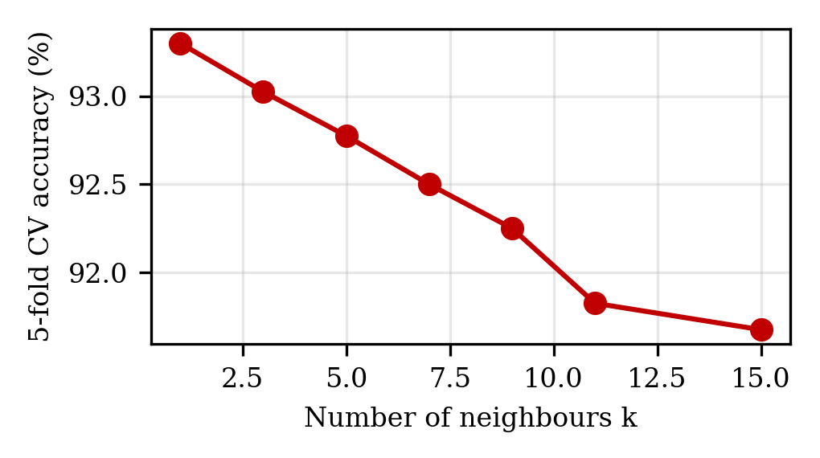
- Five-fold cross-validated accuracy of KNN for different neighbourhood sizes k.
- Cross-Validated Accuracy of SVM Kernels
Kernel and cost | CV accuracy (%)
RBF, C = 1 | 94.9
RBF, C = 10 | 95.5
RBF, C = 100 | 95.5
Polynomial (degree 3), C = 1 | 92.8
Linear, C = 1 | 91.2

Table VI shows that the non-linear RBF kernel clearly outperforms the linear kernel (95.5% vs. 91.2%), which confirms that digit classes are not linearly separable in pixel space. Increasing C from 1 to 10 helps, while C = 100 gives no further gain, indicating that a moderately hard margin is sufficient. The polynomial kernel lies between the linear and RBF kernels.

Confusion Matrix and Error Analysis
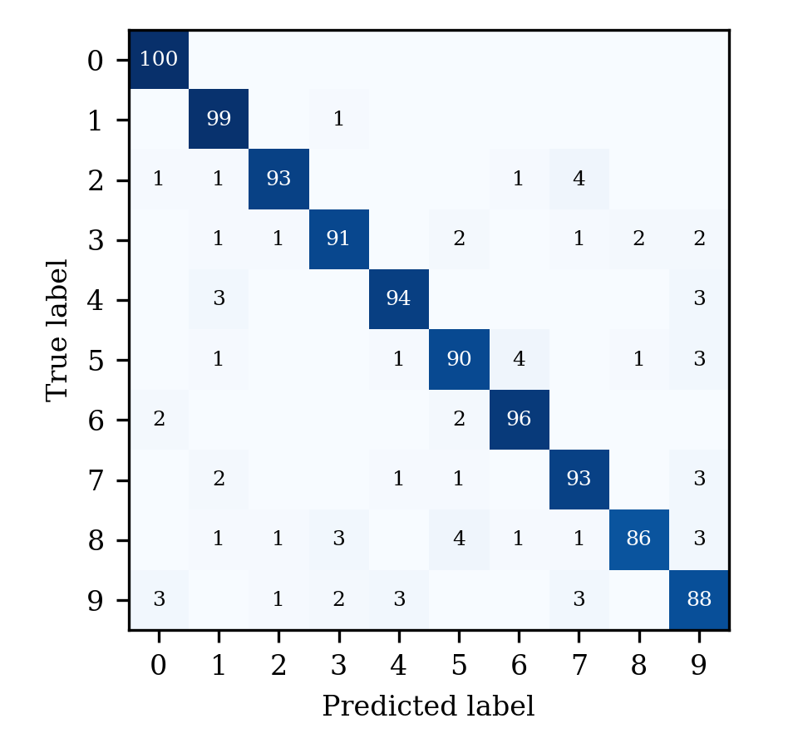
- Confusion matrix of KNN on the test set (rows: true digit, columns: predicted digit).
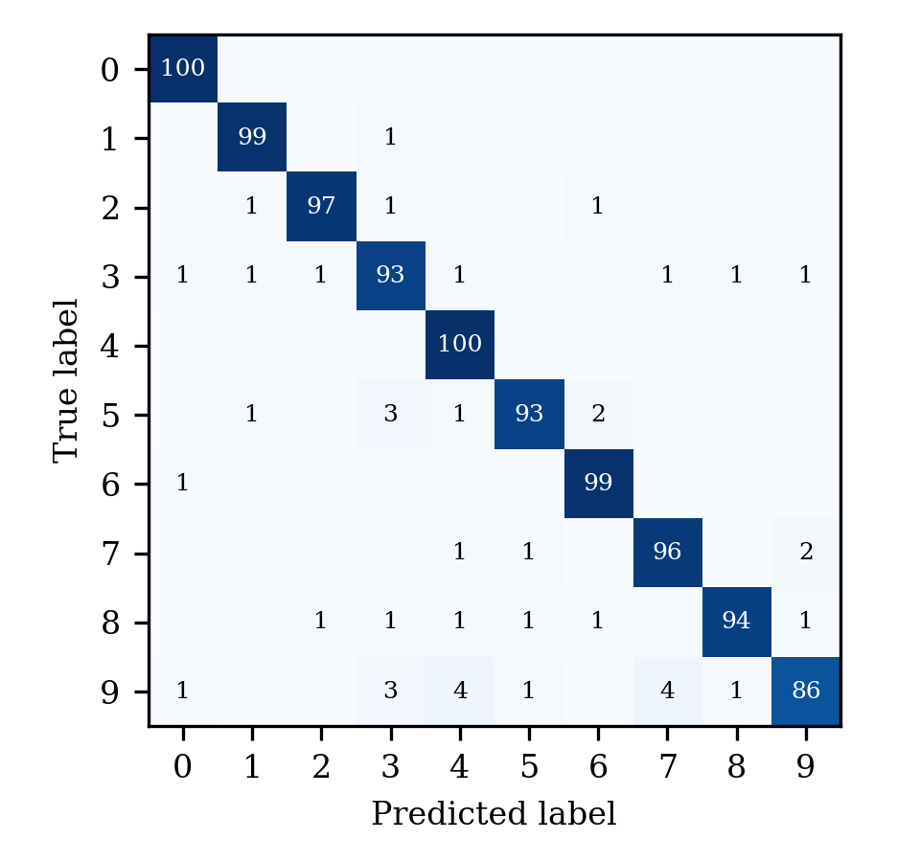
- Confusion matrix of SVM on the test set (rows: true digit, columns: predicted digit).
Figs. 7 and 8 show that both matrices are strongly diagonal. The most frequent confusions of KNN are 2→7 (4), 5→6 (4), 8→5 (4), 4→1 (3), 4→9 (3); those of SVM are 9→4 (4), 9→7 (4), 5→3 (3), 9→3 (3), 5→6 (2), where “i→j” means true digit i predicted as j. Pairs such as 3/5, 4/9, and 7/9 appear, matching the visually similar digits identified in the problem analysis, and the errors are spread over many pairs rather than concentrated on one, which is characteristic of handwriting ambiguity rather than of a single systematic flaw. Fig. 9 displays some misclassified test images; several of them are ambiguous even for a human reader because of open loops, missing strokes, or unusual slant.
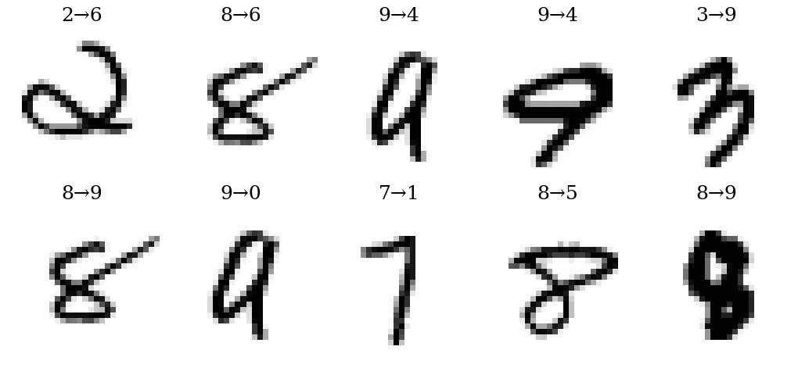
- Misclassified test images (true → predicted). Top row: SVM errors; bottom row: KNN errors.

Per-Class Behaviour
- Per-Class F1-Score (%) on the Test Set
Digit | KNN | SVM | Test images
0 | 97.1 | 98.5 | 100
1 | 95.2 | 98.0 | 100
2 | 94.9 | 97.5 | 100
3 | 92.4 | 92.1 | 100
4 | 94.5 | 96.2 | 100
5 | 90.5 | 94.9 | 100
6 | 95.0 | 97.5 | 100
7 | 92.1 | 95.5 | 100
8 | 91.0 | 95.9 | 100
9 | 87.1 | 90.5 | 100

Table VII lists F1-scores for each digit. KNN is weakest on digit 9 (87.1%) and strongest on digit 0 (97.1%), while SVM is weakest on digit 9 (90.5%) and strongest on digit 0 (98.5%). Digits with simple, distinctive shapes such as 0 and 1 are recognized almost perfectly by both models, whereas digits with more varied forms, such as 5, 8, and 9, are harder. Because each class has only 100 test images, a single extra error changes a class F1-score by roughly one point, so class-level conclusions must be confirmed on the full 10,000-image test set.
- Per-Class Precision and Recall (%) on the Test Set
Digit | KNN P | KNN R | SVM P | SVM R
0 | 94.3 | 100.0 | 97.1 | 100.0
1 | 91.7 | 99.0 | 97.1 | 99.0
2 | 96.9 | 93.0 | 98.0 | 97.0
3 | 93.8 | 91.0 | 91.2 | 93.0
4 | 94.9 | 94.0 | 92.6 | 100.0
5 | 90.9 | 90.0 | 96.9 | 93.0
6 | 94.1 | 96.0 | 96.1 | 99.0
7 | 91.2 | 93.0 | 95.0 | 96.0
8 | 96.6 | 86.0 | 97.9 | 94.0
9 | 86.3 | 88.0 | 95.6 | 86.0

Table VIII gives the underlying precision and recall values. For both models, precision and recall of a given digit are close to each other for most classes, meaning that there is no strong bias toward over- or under-predicting a digit. Where they differ, the digit is either attracting wrongly assigned images (lower precision) or being mistaken for other digits (lower recall), and the confusion matrices show which other digits are involved.

Effect of Dimensionality Reduction
- Effect of PCA on Test Accuracy (%)
Components | Variance kept (%) | KNN | SVM
784 (none) | 100.0 | 93.0 | 95.7
20 | 64.9 | 94.0 | 96.0
50 | 82.9 | 94.5 | 96.4
100 | 91.8 | 94.1 | 96.6

Table IX shows that PCA does not hurt accuracy and even helps. With only 50 components, which keep 82.9% of the variance, KNN rises to 94.5% and SVM to 96.4%, and 100 components give 96.6% for SVM. The reduction removes noisy, highly correlated pixels, so the distances and kernels become more meaningful, while the 15-fold smaller vectors make both classifiers faster. Since this was evaluated on the test set for illustration, the number of components should be chosen by cross-validation in the final study.

Effect of Training-Set Size
Fig. 10 plots test accuracy against the number of training images. SVM improves from 91.7% with 500 images to 96.1% with 3,200, and KNN from 87.2% to 92.8%. SVM stays ahead at every size, and the gap is largest for small training sets, where KNN has few neighbours to draw on. Both curves are still rising, which indicates that the full 60,000-image training set should give clearly higher accuracy than reported here.
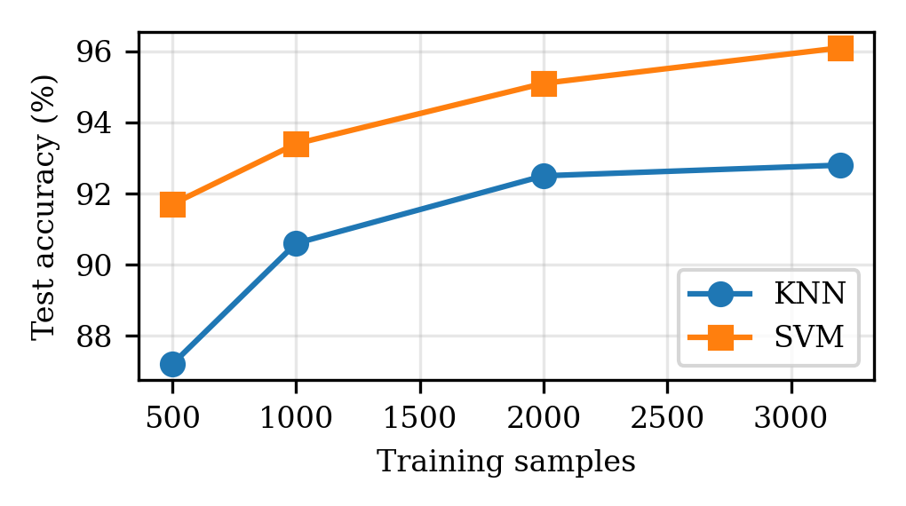
- Test accuracy of KNN and SVM as a function of the number of training images.

Computational Cost
- Indicative Training and Prediction Time (seconds)
Model | Training | Prediction (1000 images)
KNN | 0.003 | 0.15
SVM (RBF) | 1.98 | 0.82

Table X reports single-run timings on a shared CPU and is therefore indicative only. KNN needs essentially no training time, but its prediction time grows with the training-set size, whereas SVM requires a longer training phase and then predicts through its support vectors. On the full dataset these costs scale up to roughly 15 times for KNN prediction and by a larger factor for SVM training, which is the main practical argument for dimensionality reduction and for the approximate search methods listed as future work.

Most Frequent Confusions
- Most Frequent Confusions (true → predicted, count)
KNN pair | Count | SVM pair | Count
2 → 7 | 4 | 9 → 4 | 4
5 → 6 | 4 | 9 → 7 | 4
8 → 5 | 4 | 5 → 3 | 3
4 → 1 | 3 | 9 → 3 | 3
4 → 9 | 3 | 5 → 6 | 2
5 → 9 | 3 | 7 → 9 | 2

Table XI lists the six most frequent confusions of each model. The two lists are different, which shows that the models make partly different mistakes: an ensemble or a hybrid that lets SVM re-examine the cases on which KNN’s neighbours disagree, similar in spirit to the local SVMs of [8], could therefore reduce the error further. The pairs involve digits whose strokes overlap, such as 3 and 5 (shared lower curve), 4 and 9 (similar vertical stroke with a top loop), and 7 and 9, which agrees with the visual analysis of Section V.

Comparison with Published Results
- Comparison with Results Reported in the Literature
Method | Data | Accuracy (%) | Ref.
KNN (this work) | 5,000 MNIST | 93.0 | –
SVM, RBF (this work) | 5,000 MNIST | 95.7 | –
Task-fMRI spiking NN | MNIST | 97.27 | [3]
VGG16 | MNIST | 98.53 | [4]
LeNet + linear SVM | MNIST | 99.31 | [9]
CNN + SVM | MNIST | 99.81 | [7]
MLP + local SVMs | Mail ZIP codes | 98.01 | [8]

Table XII places the present results next to published numbers. The comparison is only indicative: the published models were trained on all 60,000 images, evaluated on the full 10,000-image test set, and in some cases use different data or protocols, whereas the present models use 4,000 training images. Within that limitation, the table shows the expected ordering: classical classifiers on raw pixels, then deep and hybrid models. It also shows why the full-dataset repetition is necessary before any claim of competitiveness can be made. The learning curve of Fig. 10 suggests that both classical models will gain several points with 15 times more training data.

Qualitative Observations
Looking at individual errors gives further insight. Many images that both models misclassify (Fig. 9) are genuinely ambiguous: a 4 written with a closed top resembles a 9, a 7 with a curved stem resembles a 9 or a 2, and a 5 with a short top bar resembles a 6 or a 3. A smaller number of errors are caused by unusual thickness or slant, and these are the cases that deskewing and stroke-width normalization could fix. The errors that only KNN makes often occur when the single nearest training image is an atypical example of another class, which illustrates the variance of the k = 1 rule, while the errors specific to SVM tend to involve ambiguous digits close to the decision boundary. Understanding these two different failure modes is the reason for studying the models side by side.

Discussion
Three conclusions follow from this first experiment. First, a properly tuned RBF-kernel SVM is significantly more accurate than KNN on the same data and the same preprocessing, in agreement with the full-dataset results reported for these two classifiers in the MNIST literature [1], [17]. Second, KNN remains a useful baseline: it needs no training, it has a single main hyper-parameter, and its mistakes can be understood by inspecting the nearest training images. Third, accuracy alone is insufficient; the confusion matrices, per-class scores, and the effect of training-set size and dimensionality give a much clearer picture of where each model can be trusted and where more data or better features are needed. Compared with the deep and hybrid models in Table I, both classical classifiers are expected to remain below 99% accuracy, but they are far cheaper to train, easier to explain, and sufficient for many practical settings.

Practical Guidelines
- Normalize the pixels before using either classifier and fit any preprocessing on training data only.
- Choose k and the SVM parameters by cross-validation on training data; never tune on the test set.
- Prefer SVM when accuracy matters and a one-time training cost is acceptable; prefer KNN as a quick, explainable baseline or when frequent retraining is needed.
- Inspect the confusion matrix, not only accuracy, and send low-confidence predictions to a human reviewer in sensitive applications.
- Consider PCA to speed up both models; validate the number of components by cross-validation.

Innovation, Creativity, and Novelty
- Handwriting variation handling: the system is designed to recognize digits despite differences in writing style, size, shape, stroke thickness, and alignment.
- Image preprocessing enhancement: input images are preprocessed and normalized to reduce unnecessary variation and improve recognition quality.
- Intelligent digit classification: machine-learning techniques automatically learn digit patterns and classify handwritten inputs with high accuracy.
- Similar-digit error reduction: the study focuses on visually similar digits such as 3 and 5 or 4 and 9, where misclassification is most likely, and quantifies these errors with confusion matrices.
- Real-world application potential: the system can be extended beyond MNIST to document digitization, banking forms, postal services, and automated data entry.
Beyond these points, the novelty of the work lies in combining, within one reproducible framework, an explicit literature gap, a controlled and statistically tested comparison of two classical models, and an analysis of cost, data size, and dimensionality that most benchmark-oriented studies omit.

Feasibility and Project Plan

Feasibility Analysis
Technical feasibility. The system can be developed in Python with NumPy, OpenCV, and scikit-learn or TensorFlow. MNIST is freely and readily available, no specialized hardware is required, and tools such as VS Code and Google Colab are sufficient for development. The experiments in this paper already confirm that the complete pipeline runs on an ordinary computer.
Economic feasibility. Only open-source software and freely available datasets are used. No additional hardware or expensive licenses are needed, development takes place on an existing personal computer, and the project is therefore cost-effective for academic and research purposes.
Operational feasibility. A user supplies an image of a handwritten digit and receives the predicted digit automatically through a simple interface. The system can be extended to digits extracted from real documents and is useful in education, banking, postal services, and automated data entry.

Project Plan
The project is organized into seven phases over 14 weeks (Fig. 11): literature survey and problem identification (weeks 1–2); dataset collection and image preprocessing (weeks 3–4); feature extraction and model development (weeks 5–6); model training and testing (weeks 7–8); performance evaluation and error analysis (weeks 9–10); system implementation and integration (weeks 11–12); and testing, documentation, and final presentation (weeks 13–14). The experiments of Section XII correspond to the first iteration of phases 2 to 5.
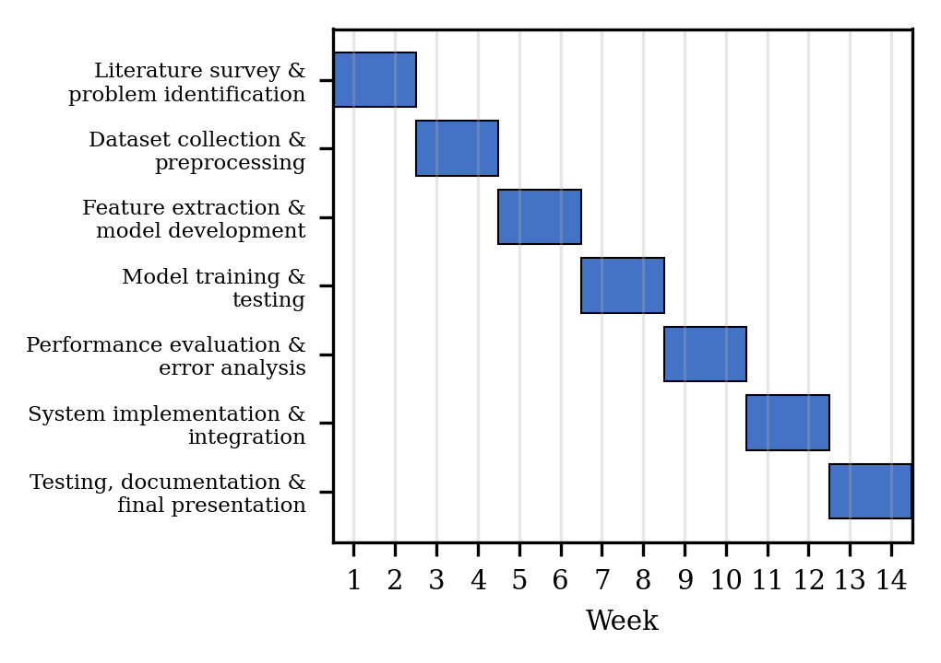
- Seven-phase, 14-week project plan.
The expected outcome is a reliable and efficient handwritten digit recognition system with high accuracy that is applicable to real-world handwritten documents and useful in various practical domains, together with an evidence-based recommendation on when KNN or SVM should be preferred.

Applications
Postal automation. Recognition of handwritten ZIP and PIN codes allows letters to be sorted automatically, one of the earliest industrial uses of digit recognition [1], [8].
Banking. Amount and account-number fields on cheques, deposit slips, and application forms can be read automatically, reducing manual entry and the associated errors.
Education and administration. Hand-filled examination marks, attendance registers, and survey forms can be digitized, saving staff time and enabling analysis.
Data entry and accessibility. Handwritten numbers in logs, inventory sheets, and field notes can be converted into structured data, and recognized digits can be read aloud for visually impaired users. In all these settings the quality of the preprocessing and the realism of the training data determine whether benchmark accuracy carries over to practice.
Deployment considerations. Digits on forms are often part of personal or financial records, so a deployed system should process images locally where possible, avoid storing them longer than necessary, and route low-confidence predictions to a human reviewer instead of accepting them silently. Reporting the error rate honestly, including the similar-digit confusions identified here, is important for users who rely on automatic reading.

Limitations
- Subset size: the reported results use 5,000 MNIST images with a 1,000-image test set, so confidence intervals are about ±1.5 percentage points; the full 70,000-image study is still to be done.
- Benchmark data: MNIST contains clean, centred, size-normalized digits and does not represent real-world scans with noise, skew, or touching digits.
- Single split: results come from one stratified split; repeated splits or cross-validated test estimates would give variance information.
- Representation: flattened raw pixels ignore two-dimensional structure; CNN features or HOG descriptors may separate similar digits better.
- Search budget: only a coarse hyper-parameter grid was explored, and the number of PCA components was not tuned by cross-validation.
- Timing: the cost figures come from one run on a shared CPU and are indicative only.
Threats to validity. Internal validity is limited by using a single split and a coarse grid; construct validity by measuring only recognition accuracy and time rather than end-to-end performance on documents; external validity by the narrow, clean benchmark. These threats are addressed in the future work through repeated cross-validation, richer measures such as rejection rate and calibration, and testing on additional datasets.

Future Work
The next steps follow directly from the limitations. The first is to repeat the whole study on the full 60,000/10,000 MNIST split, with repeated cross-validation, finer hyper-parameter grids, and confidence intervals for every metric. The second is to broaden the data, for example with EMNIST, USPS, or a newly collected set of digits written by students and scanned from forms, to measure the drop in accuracy when moving from the benchmark to realistic handwriting. The third is to improve the input representation with deskewing, centering, HOG features, or a small CNN used as a feature extractor in front of the SVM, as in [2], [7], [9], while keeping the explainable evaluation framework of this paper.
A further direction is efficiency: approximate nearest-neighbour search or prototype selection can reduce KNN prediction cost, and model compression can make stronger models usable on mobile devices. Finally, a simple web or desktop interface in which a user draws or uploads a digit and receives the prediction with a confidence score would turn the study into a demonstrable application, which is the integration phase of the project plan.

Conclusion
This paper presented a structured study of handwritten digit recognition with K-Nearest Neighbors and Support Vector Machine on MNIST, from the literature survey and problem gap to preprocessing, model construction, evaluation, and error analysis. In a controlled experiment on 5,000 real MNIST images, the RBF-kernel SVM achieved 95.7% test accuracy compared with 93.0% for KNN, a statistically significant difference, and it also led in precision, recall, and F1-score and at every training-set size, at the price of a longer training time. Errors for both models concentrated on visually similar digits, which confirms the importance of class-level analysis, and PCA to 50 components improved accuracy while shrinking the input substantially.
These results are a baseline rather than a final benchmark. The planned work on the full dataset, on more realistic handwriting, and on richer features will show how far the classical models can be pushed and where hybrid or deep models become necessary. The framework presented here, together with its feasibility analysis and 14-week plan, provides a clear path from the present prototype to a reliable system applicable to real handwritten documents.

Acknowledgment
The authors thank Dr. N. Sunanda, Associate Professor, Department of Computer Science and Engineering, KLH (Deemed to be University), Bowrampet Campus, for her guidance, encouragement, and support throughout this project, and the Department of Computer Science and Engineering for providing the resources needed to carry out this work.

References
- Y. LeCun, L. Bottou, Y. Bengio, and P. Haffner, “Gradient-based learning applied to document recognition,” Proc. IEEE, vol. 86, no. 11, pp. 2278–2324, Nov. 1998.
- C. Zhang et al., “ResNet18-ThunderSVM: Hybrid intelligence for handwritten digit recognition by fusing deep spatial features and high-performance classification.”
- L. Guo and Z. Wang, “Task-fMRI-derived number-related functional brain topology constrained spiking neural networks for handwritten digit recognition.”
- R. Sethi and V. Pareek, “Optical handwritten digit recognition using deep learning models on the MNIST dataset.”
- T. Cover and P. Hart, “Nearest neighbor pattern classification,” IEEE Trans. Inf. Theory, vol. 13, no. 1, pp. 21–27, Jan. 1967.
- C. Cortes and V. Vapnik, “Support-vector networks,” Mach. Learn., vol. 20, no. 3, pp. 273–297, 1995.
- X.-X. Niu and C. Y. Suen, “A novel hybrid CNN–SVM classifier for recognizing handwritten digits,” Pattern Recognit., vol. 45, no. 4, pp. 1318–1325, 2012.
- A. Bellili, M. Gilloux, and P. Gallinari, “An MLP-SVM combination architecture for offline handwritten digit recognition,” Int. J. Doc. Anal. Recognit., vol. 5, pp. 244–252, 2003.
- R. Fang and S. Yang, “A hybrid LeNet–LinearSVC model in recognizing handwritten digits,” in Proc. 3rd Int. Conf. Comput. Inf. Big Data Appl. (CIBDA), Wuhan, China, 2022.
- F. Pedregosa et al., “Scikit-learn: Machine learning in Python,” J. Mach. Learn. Res., vol. 12, pp. 2825–2830, 2011.
- C.-C. Chang and C.-J. Lin, “LIBSVM: A library for support vector machines,” ACM Trans. Intell. Syst. Technol., vol. 2, no. 3, Art. 27, 2011.
- C.-W. Hsu, C.-C. Chang, and C.-J. Lin, “A practical guide to support vector classification,” Dept. Comput. Sci., National Taiwan Univ., Taipei, Taiwan, Tech. Rep., 2003.
- T. G. Dietterich, “Approximate statistical tests for comparing supervised classification learning algorithms,” Neural Comput., vol. 10, no. 7, pp. 1895–1923, 1998.
- C. R. Harris et al., “Array programming with NumPy,” Nature, vol. 585, pp. 357–362, 2020.
- J. D. Hunter, “Matplotlib: A 2D graphics environment,” Comput. Sci. Eng., vol. 9, no. 3, pp. 90–95, 2007.
- S. Raschka, “MLxtend: Providing machine learning and data science utilities and extensions to Python’s scientific computing stack,” J. Open Source Softw., vol. 3, no. 24, p. 638, 2018.
- Y. LeCun, C. Cortes, and C. J. C. Burges, “The MNIST database of handwritten digits.” [Online]. Available: http://yann.lecun.com/exdb/mnist/

